1. Write a Prolog Program to Sum the Integers from 1 to n.

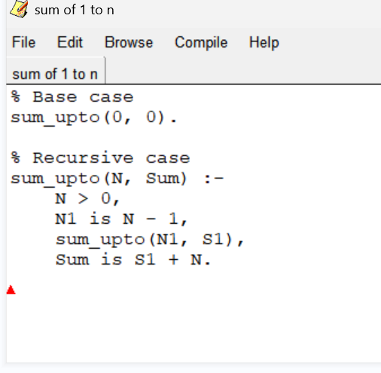

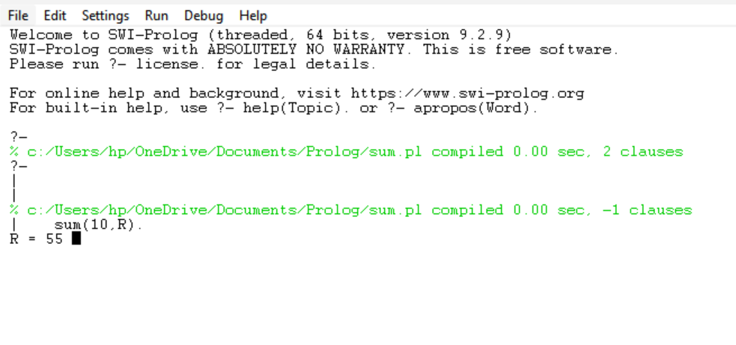

1. Write a Prolog Program for A DB WITH NAME, DOB.

